Objective Questions for chapter 3
- What the definition of Transition Graph ?
  - Finite number of states, at least one of which is not start state and some (maybe none) final states.
  - Finite set of input letters (Σ) from which output strings are formed.
  - Finite set of transitions that show how to go from one state to another based on reading specified substrings of input letters, possibly even the null string (Λ)
  - Finite number of states, at least one of where is start state and some (maybe none) final states.

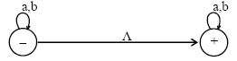
- Consider the Language L , defined over Σ = {a, b} of all strings including Λ. The language L may be accepted by the following TG

a.
. 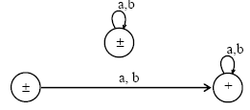
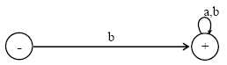
b.

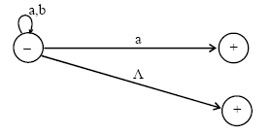
c.

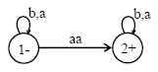
d.

- What the meaning of Generalized Transition Graphs ?
  - Finite number of states, at most one of which is start state and some (maybe none) final states.
  - Finite set of input letters (G) from which input strings are formed.
  - Directed edges connecting some pair of states labeled with non regular expression.
  - the labels of not transition edges are corresponding regular expressions

- Consider the Language L of Strings, defined over Σ = {a, b}, beginning with and ending in different letters. The language L may be expressed by the following regular expression a(a + b)*b + b(a + b)*a. This language may be accepted by the following FA
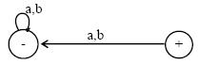
a.

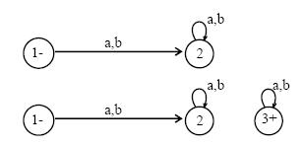
b.

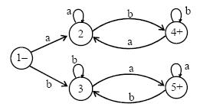
c.

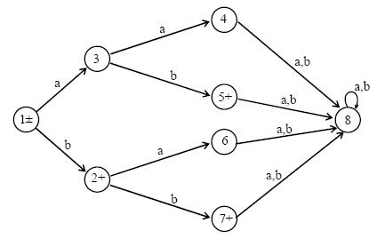
d.

5. Consider the language L = {aa, bab, aabb, bbba}, defined over Σ ={a, b}, expressed by aa + bab + aabb + bbba OR aa (Λ + bb) + b (ab + bba). The above language may be accepted by the FA as shown aside..
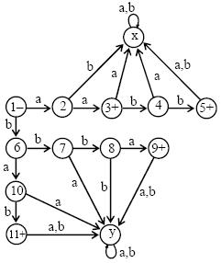
a. b.
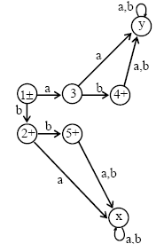

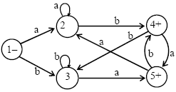
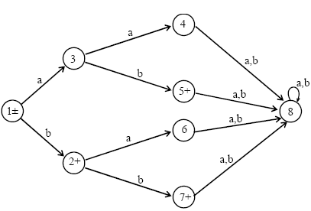
- d.

6. Consider the language FA corresponding to r1+r2 can be determined as L = {w belongs to {a,b}*: w does not end in aa}. Which regular expression that express above language :
a. Λ + a + b + (a+b)*(aa+ab+ba+bb)
b. Λ + a + b + (a+b)*(ab+ba)
c. Λ + a + b + ab + (a+b)*(ab+ba)
d. Λ + a + b + (a+b)*(ab+ba+bb)

- Consider the language L = {w belongs to {a,b}*: length(w) >2 and w neither ends in aa nor bb}. Which regular expression that express above language :
  - (a+b)*(ab+ba)
  - a*(a+b)*(ab+ba)
  - b*(a+b)*(ab+ba)
  - (a+b)*(ab-ba)

8. Consider the language L = {A, b, ab, bb}, defined over G ={a, b}, expressed by K + b + ab + bb OR K + b (K + a + b). The language L may be accepted by the FA as shown aside

a. b.

c. d.

9. Consider the language L of strings, defined over G={a, b}, having double a’s or double b’s, The language L may be expressed by the regular expression (a+b)* (aa + bb) * (a+b). The language may be accepted by the following FA
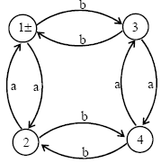
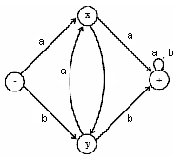
a. c.

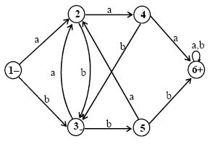
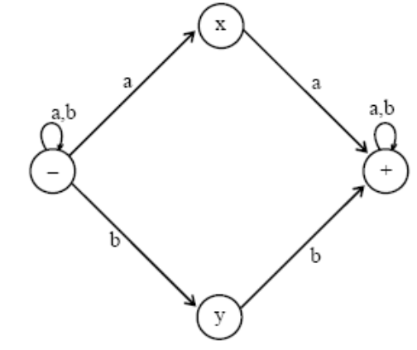
- d.

10. Consider the Language L, defined over G = {a, b} of all strings including A. The language L may be accepted by the following FA

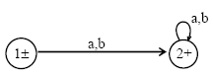
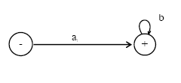
- c.

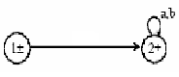
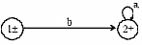
- d.

